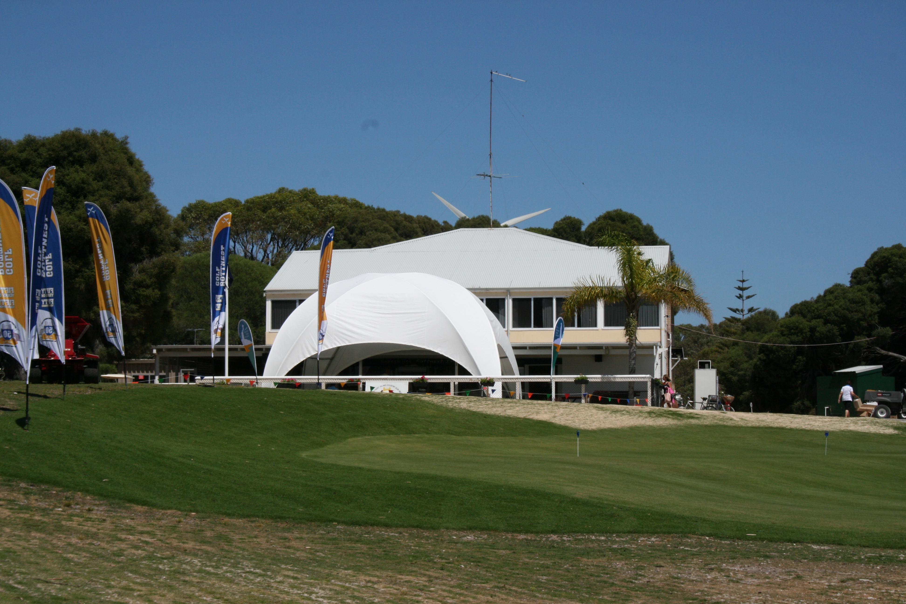

Members and friends of Rottnest Island Golf Club,

Greetings for 2014.
This year heralds the start of a new era with an improved golf course for members to play our tradition competition rounds during the club’s winter season. It is now time to renew your membership for 2014.
The Golf Club AGM is set for Sunday 9th February 2014 at Maylands Peninsular Golf Course. Start time 1730hrs. Please fill out and send in your notice of attendance or apology. There are some important club decisions that need your attendance to cast a vote.
Attached is a copy of notification of attendance form and advice of your intention to play the 9 hole event. Information on the adjustment to handicap system for Golflink is also included.
Take a tour of the club web site. There are constant information updates being added and photos from opening event in November. Members can add your own photos by logging into the Flickr site by clicking through the photo gallery page and clicking the upload button at Flickr. The login is : golfricc and password (case sensitive) Member2013 .

January 2014
Rottnest Island Country Club Inc
Annual General Meeting 2014 – Notice to Members
In accordance with Rule 23.1(a) of THE ROTTNEST ISLAND COUNTRY CLUB INC CONSTITUTION & RULES 2001 (rev4), notice is given that the Annual General Meeting of the club is to be held on Sunday 9 February 2014 at the Maylands Peninsula Golf Course, Swan Bank Road, Maylands at 5.30 pm.
Although it is acknowledged that this rule states that the AGM must be held “on or before the last day of November each year”, we trust that members will bear with the committee in what we believe was an extraordinary year, with the last game of the year not being played until 17 November – allowing for the Christmas season it was decided to hold off until February.
Golf: The meeting will follow a 9 hole Stableford club event, which will play off from 1.30. A tear-off entry form is at the end of this notice for your completion and return to me so that we may cater for the golf and afters, as well of course to get an idea of numbers for the meeting.
Those members that believe they have the time, commitment and passion are encouraged to nominate for the Committee – a nomination form is attached to this notice with instructions.
For members that do not have the time for committee but assist at club functions, you are definitely encouraged to continue in that vein – it’s a great help.
All members of the RICC Inc are encouraged to attend the AGM.
Family, friends and supporters are also welcome as observers and to enjoy some post meeting fellowship and discussion on the 2013 season that was, as well as the 2014 season that will be.

Best regards,

Phil

Phil Bray
Secretary – Rottnest Island Country Club Inc 2013
0416 022 130

Rottnest Island Country Club Inc
Annual General Meeting 2014
AGM Agenda

  - President’s welcome and opening; attendance sheet reminder
  - Apologies
  - Approve the minutes of the previous Annual General Meeting held Sunday 28 October 2012. (A copy supplied at meeting)
  - Business arising from the previous AGM
  - Receive the President's Report on the activities of the RICC for the 2013 year.
  - Receive the Treasurer's Report on the receipts and payments for the period ending 31 December 2013.
  - Special resolution to alter the Constitution and Rules of the Club:

“THE ROTTNEST ISLAND COUNTRY CLUB INC CONSTITUTION & RULES will be amended to delete the word ‘THE’ and replace the word ‘COUNTRY’ with the word ‘Golf’ wherever the name of the club is mentioned, which ultimately alters the name to Rottnest Island Golf Club Inc.; such alteration also requires the replacement of the country club logo that shows the two quokkas on the shield, with the golf club logo that shows the single quokka over the map of the island, all subject to acceptance by the relevant government authority.”

Note to members: In accordance with rule 4.5, “A majority of seventy five per cent (75%) of the financial members present at such meeting is required to pass the resolution to alter the Constitution and Rules of the Club.”

  - To elect the Office Bearers and Committee for 2014
    - President
    - Vice President
    - Secretary
    - Treasurer
    - Patron/s
    - Auditor (Rule 27.1(a)
Notes regarding nominations for the committee
- All Committee positions are up for election each year; and
- Pursuant to THE ROTTNEST ISLAND COUNTRY CLUB INC CONSTITUTION & RULES 2001 (rev4), all Committee Members must be financial members of the Rottnest Island Country Club Inc at the time of the AGM.
  - Hand over to the 2014 president to introduce the incoming committee and proceed with the meeting.
  - To elect the match committee for 2014
    - Captain
    - Handicapper
  - General Business
Special Note to Members: It is of assistance that preliminary notice of items of general business are advised to the Secretary at least seven days prior to the meeting for inclusion in the agenda.

    - Non home members will no longer be separated from home members, which means this group’s subs will be increased from $75 to $100 for season 2014

    - Membership is categorised in accordance with the club rules:
      - Ordinary member,
      - Junior member,
      - Life member,
      - Honorary member, and
      - Transient member
    - Weekends for events in 2014:
      - Chairman’s Cup / Opening 14-16 Mar
      - Rottnest Classic 23-25 May
      - Rottnest Cup & Ledger Plate 22-24 Aug
      - Closing 31 Oct-2 Nov
  - Close meeting and enjoy the incoming President’s hospitality.

Notice of attendance
Rottnest Island Country Club Inc – Golf & Annual General Meeting
Sunday 9 February 2014

I, (name) ____________________________________, will be attending on this day and will

- Play in the 9 hole Stableford golf at 1.30 YES / NO (delete one)

Number of players: ______ Names: _______________________________
_______________________________
_______________________________
_______________________________

- Be present at the AGM at 5.30 YES / NO (delete one)

Number of attendees: ______

To – All Australian Golf Clubs

Dear All,

I am writing to advise you that all GOLF Link services are now online with the complete new GA Handicap System.

Note that we are currently operating the GOLF Link public website (ie www.golflink.com.au) at reduced functionality in order to manage the load on the servers – at this stage we intend to phase in full functionality throughout Friday. We are also aware that a couple of Tier 3 providers have decided to wait until Friday to bring their clubs fully online.

Please be aware that there will be loading pressures on some GOLF Link services over the next few days and we ask that you please bear with us during this time. We do regret any inconvenience that may be experienced by clubs or golfers.

Should you have any queries over the next few days regarding one of the GOLF Link systems, I would encourage you to contact the GOLF Link Customer Centre via email at help@golflink.com.au, or by phone on 1300 650 750. Any queries regarding a Tier 3 third-party software system should naturally be directed to the relevant software provider.

Please contact me with any general queries regarding the new GA Handicap System.
Kind regards,

Simon Magdulski | Director – Rules & Handicapping | Golf Australia
Direct 03 9626 5023  Mobile 0409 214 320   | Level 3, 95 Coventry Street, South Melbourne, Victoria 3205 Australia  Telephone 03 9626 5050 | Facsimile 03 9626 5095  Website: www.golfaustralia.org.au


Nomination for position
Management &/or Match Committee

To the Secretary:

Rottnest Island Golf Club;

I, …………………………………………….. being a duly qualified and financial member of the Rottnest Island Golf Club herein nominate …………………….…….. …..
to position on the Management &/or Match Committee for club season ……………
for determination by vote in proceedings of the club’s Annual General Meeting to be held on ………………..…
Position Nominated for; ………………………………………………………………………
Signed by the Nominator: …………………………..……………. Dated: ………………..

I, …………………………………………….. being a financial and duly qualified member of the Rottnest Island Golf Club herein second the above nomination;
Signed by the Seconder: ……………………..…………………. Dated: ……..…………

I, …………………………………………….. being a financial and duly qualified member of the Rottnest Island Golf Club herein accept the above nomination;
Signed by the nominee: …………………………………………. Dated: ……..…………

* * * * *

