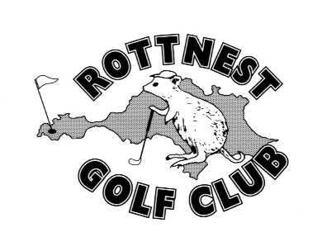**Rottnest Island Golf Club**

A.B.N. 5171 7058 424

**All communications to:**

**RIGC, PO Box 1399 Fremantle, WA 6959**

**Email:** [**info@rottnestgolf.org**](mailto:info@rottnestgolf.org)

|  |  |
| --- | --- |
| **Entry Form** | **RIGC 2019 Rottnest Island Cup and Ledger Plate**  **16th-18th August 2019** |

Please complete with relevant costs and return form and payment **by Friday 2nd August 2019**

**Your Details: Note: One entry form per player**

|  |  |
| --- | --- |
| Name |  |
| GolfLink # |  |
| Address |  |
| Telephone |  |
| Email |  |
| Membership Status |  |

**Getting there:**

|  |  |  |  |  |
| --- | --- | --- | --- | --- |
| Are you travelling on Ferries to get to and from the island? | | | Yes No | |
| If Yes, please advise | Ferry Company | Mainland Port | Day | Time |
| To the Island |  |  |  |  |
| From the Island |  |  |  |  |

**The Golf**

|  |  |  |  |
| --- | --- | --- | --- |
|  | **Friday** | **Saturday** | **Sunday** |
|  | **Presidents Trophy** | **Rottnest Cup and Ledger Plate** | **Elgar O'Mahony Ambrose** |
|  | 9 Hole Stableford | 18 Hole Par | Teams Ambrose |
| **Playing (Yes / No / Light meal Only)** |  |  |  |
|  |  |  |  |
| **CARTS** Do you wish to hire a powered cart over the Weekend? Please indicate days… |  |  |  |
| Do you have a medical need for the cart? (Y/N) |  |  |  |
| *There are a limited number of carts available on the island. Cart allocations will be firstly to players with medical needs, and then by order of receipt of entry.* | | | |
| For the **Saturday** Game - Prefer to be in the same playing group with: | |  | |
|  | | | |
| Will you be bringing extra people who will join us for the meals? If yes, excluding yourself, how many… | | | |
| 12 and Over |  |  |  |
| Under 12. |  |  |  |
|  |  |  |  |
| Any Special Food Requirements? |  | | |
| Name of Person this applies to… |  | | |

**Cost**

|  |  |  |  |  |  |  |
| --- | --- | --- | --- | --- | --- | --- |
| If paying by EFT, please use your membership number or surname and initial as a reference. | | | Bank Details:  BSB No.  Account No. | | Rottnest Island Country Club Inc  066-107  10206554 | |
| Fees apply for full, or part of the weekend. | | | | | | Enter Amounts |
| Playing: Golf + Meals | 2019 Financial Members | | | $70 each… | | $ |
|  | *2019 Membership Fee (if unpaid to date)* | | | *$100 each…* | | $ |
|  | Non-Financial Members and Non-Members | | | $105 each… | | $ |
| Non Playing Guests: | Meals Only: | 12 years and Over | | $50 each… | | $ |
|  |  | Under 12 years of age | | $20 each… | | $ |
|  | | | | **TOTAL** | | **$** |

**NOTE : CART HIRE FEES ARE PAYABLE DIRECT TO KARMA GOLF WHEN YOU COLLECT YOUR KEYS.**